**Audio Analysis Essentia Installation Guide**

Key/Tips for Ubuntu/Linux:

-red text- this is python code

-Gray Font: keyboard commands or code that must be implemented in the terminal.

-typing reset into the terminal will get rid of all of the clutter and give you a clean terminal

-the command cd ./blah blah blah will **C**hange the **D**irectory of the terminal

-the command ls will **L**ist the folders/files in the current directory

Step 1: Download VMware Player

Note: this will be used to run the linux based system, which our libraries are compatible with. <http://www.vmware.com/uk/products/player>

Step 2: Download the .iso file for the correct linux OS.

Note: The OS we will be using is call Ubuntu 14.10. <http://old-releases.ubuntu.com/releases/14.10/>

Step 3: Setup your virtual machine(VMware) to work with this .iso and run the Ubuntu OS.

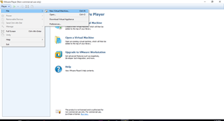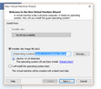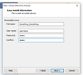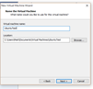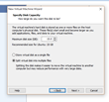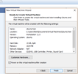

Step 4: Open your this running version of Ubuntu on the Virtual Machine

Step 5: Install python onto the linux OS.

Note: Almost all of the work done with this project is/can be done through the terminal. To open the terminal ctrl+alt+T

To install python from the terminal type: sudo apt-get install python

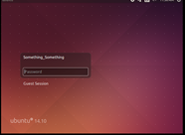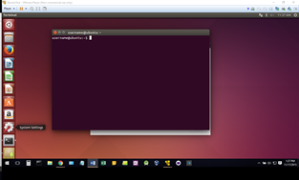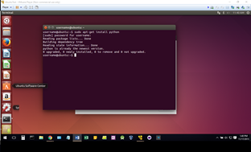

Step 6: Install Git

Note: Type: sudo apt-get install git to install git on linux, git will help us clone a repository that contains the libraries we will be using.

Side Note: This may not compile correctly a quick fix solutions are:

sudo apt-get update

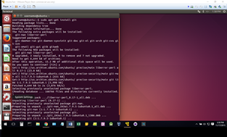

Step 7: Install Essentia using a git repository, this can be done through the terminal using

git clone <https://github.com/MTG/essentia.git>

be sure to navigate to the correct folder you would like to install essentia into before typing this command, otherwise this will just install in the current directory.(use the cd ./genericFolderName command to change the directory to genericFolderName)

Side Note: Because essentia could potentially be changed in the future we will look into installing essentia via .zip file. Steps will be as follows:{With the zip file, treat the process the same. the only difference once extracting the .zip file will be the location of the essentia folder.}

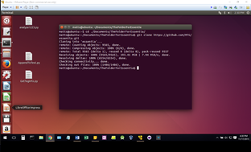

Step 8: Install Essentia Library onto Ubuntu machine using the command prompt.

Note: type: sudo apt-get install build-essential libyaml-dev libfftw3-dev libavcodec-dev libavformat-dev libavutil-dev libavresample-dev python-dev libsamplerate0-dev libtag1-dev

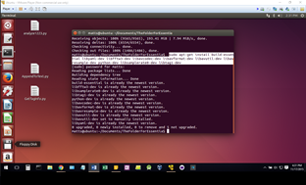

Step 9: Configure Essentia

Note: you will need to be inside the directory of the essentia folder to make the configurations to work. This is done by using cd ./EssentiaFolder Then using ./waf configure --mode=release --with-python --with-cpptests --with-examples --with-vamp

in the command prompt/terminal

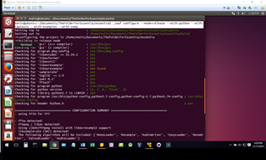

Step 10: Compile Essentia using ./waf This process takes a while...

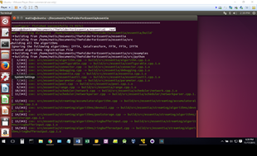

Step 10: Essentia has been compiled!!!! and you are ready to start writing python code.

Inside your python code you will need to import the essentia and essentia.standard library based on the code you are using, reference the API for details: <http://essentia.upf.edu/documentation/algorithms_reference.html>

Sample Python Code:

import essentia

import essentia.standard

import sys

filepath = sys.argv[1] # Allows users to input filename

loader = essentia.standard.MonoLoader(filename = filepath)

audio = loader()

#Dynamic comlexity returns two outputs:

#DynamicComplexiy== range and to the amount of fluctuation in loudness

#Loudness=>not necessary

def DynamicComplexity(audioInput):

Dyna = essentia.standard.DynamicComplexity()

comp = Dyna(audio)

a= (comp[0], comp[1])

return comp

print 'DynamicComplexity:'

print DynamicComplexity(audioInput = audio)

Step 11: This python code can be saved in a text editor such as notepad or linux’s version of notepad.

Note: This will be saved with the extension .py instead of .txt

Step 12: As shown in the above code, the import essentia line is included as well as the import essentia.standard.

Step 13: The def DynamicComplexity(filename) is the “function” which enables the code to be called similarly to a class.

Note: to test this function in the terminal, navigate to the folder that the python file is saved in. then use command python NameOfSavedPythonFile.py 'filename/directory/file.mp3'

Step 14: Updating to Server, in order for files to be uploaded to the database/server you will need to install pysftp, by using sudo pip install pysftp

Note: knowledge of how this portion of the code works will not be needed unless modifying where the server/database is or how it is being uploaded in which case visit:

<https://pypi.python.org/pypi/pysftp> for support.

Licensing Information:

Essentia is released under the Affero GPLv3 license. Some essentia algorithm libraries use other third party licenses which must be individually sublicensed if the product is to be released. These libraries are:

1. GPL (with dual license option to allow Commercial license. Commercial license has to be obtained from the software author)
   * FFTW - http://www.fftw.org/
   * Libsamplerate - http://www.mega-nerd.com/SRC/
   * MAD: MPEG Audio Decoder - http://www.underbit.com/products/mad/
2. LGPL (the original copyright notice as well as a copy of the LGPL has to be supplied. This can be achieved through dynamic linking)
   * Libsndfile - http://www.mega-nerd.com/libsndfile/
   * Taglib - http://developer.kde.org/~wheeler/taglib.html
   * Pthreads Win32 - http://sourceware.org/pthreads-win32/
   * XMLPP - http://sourceforge.net/projects/xmlpp/
3. Others (the original copyright notice must be retained. They can be linked dynamically or statically)
   * Libogg and Libvorbis - http://xiph.org/ogg/ (BSD-style license)
   * BZ2 - http://www.bzip.org/ (BSD-style license)
   * MersenneTwister - http://www.math.sci.hiroshima-u.ac.jp/~m-mat/MT/emt.html (BSD-style license)
   * Python - http://www.python.org/ (Python license)
   * Intel Threading Building Blocks - http://www.threadingbuildingblocks.org/ (GPL with the runtime exception)
   * Libxml2 - http://www.xmlsoft.org/ (MIT license)
   * TNT - http://math.nist.gov/tnt/ (Public domain)

See <http://essentia.upf.edu/documentation/licensing_information.html> for a complete updated listing.